# ASSIGNMENT 4

NAME : Shoyeb sanaullah tahasildar

PRN : 2020BTECS00059

BATCH : T3

**Title:** Online multiple-choice tests platform.

**Objective/Aim:**

Design and implement a system for managing online multiple-choice tests.

**Introduction:**

We implemented the MCQ exam platform using NodeJS, ReactJS and MySQL for backend, frontend and database respectively. Single sign in for teacher and student but can access different platforms accordingly. Teacher can add quiz and questions in quizzes while student can attempt those quizzes and can see their score card.

**Tech Stack:**

NodeJS, ReactJS, MySQL.

**Requirements:**

1. User management at different levels (Teachers/students)

2. Question Bank Entry form with provision of accepting images / mathematical expressions

3. Generic report generation: Should able to display/list any data.

**Procedure:**

Login page for teacher and student.

Created quiz page for teachers where they can create new quiz add questions etc.

Created update quiz page for teachers to update existing quiz.

Created quiz page for students where they can attempt quiz assigned by particular teacher.

Created scorecard page for students to view their score in particular quiz.

**Github Link:**

<https://github.com/Shoyeb-Tahasildar/assignement4.git>

**Screenshots:** 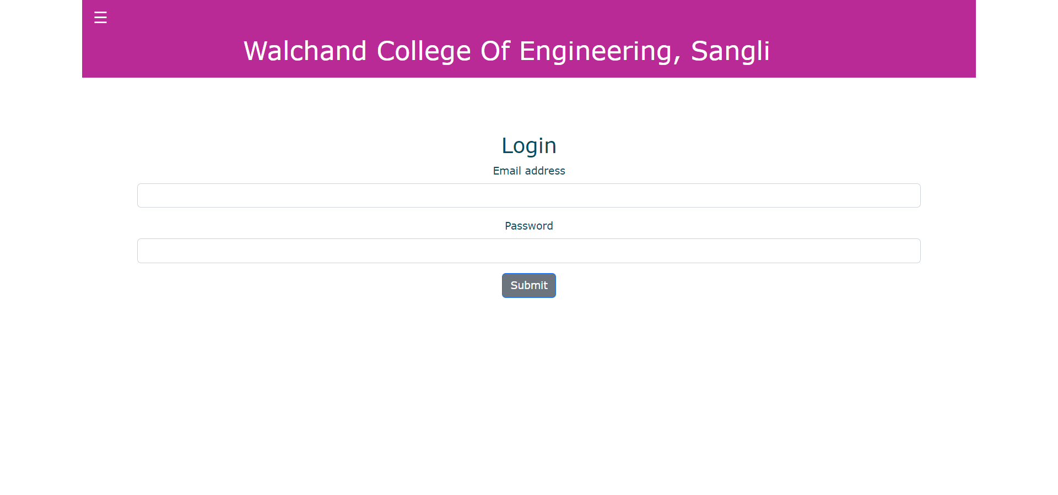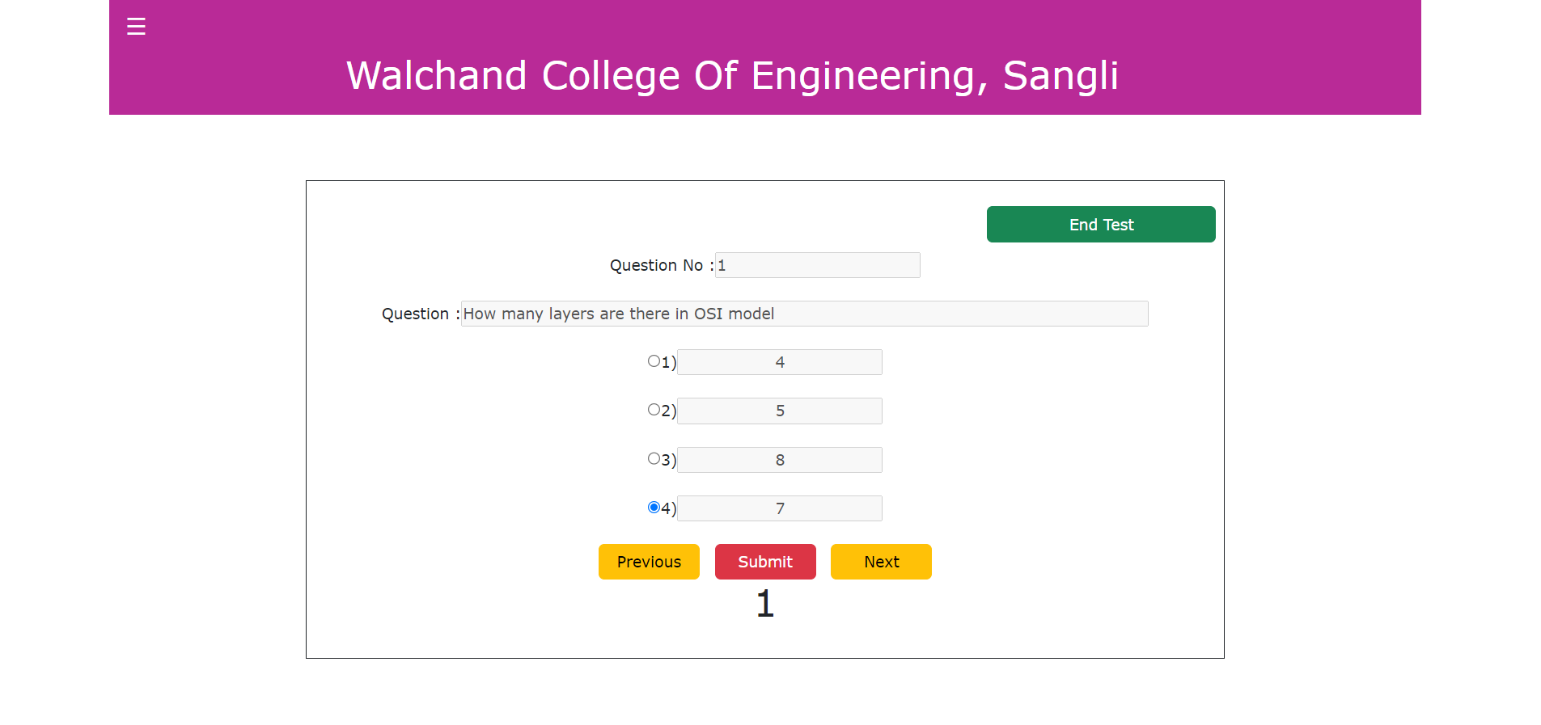

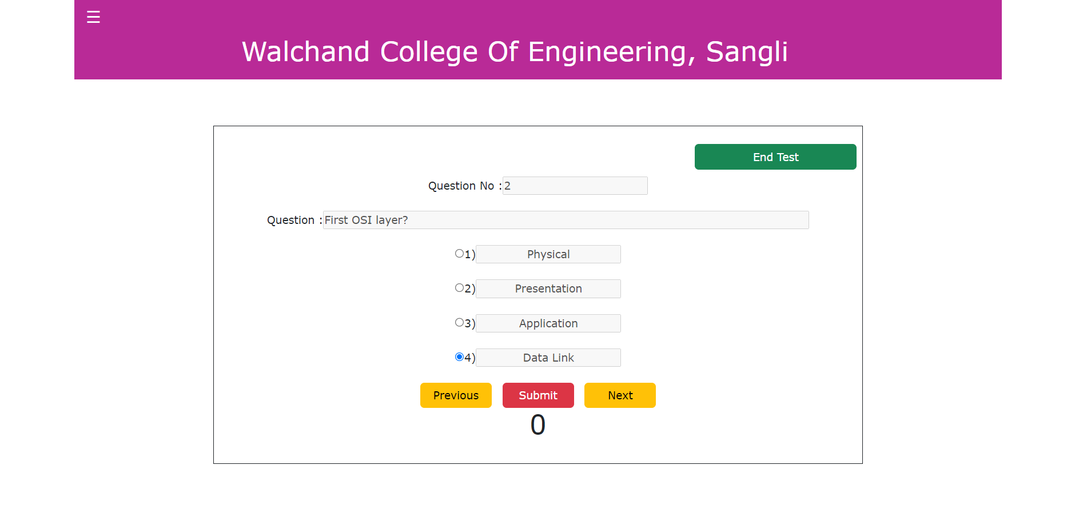

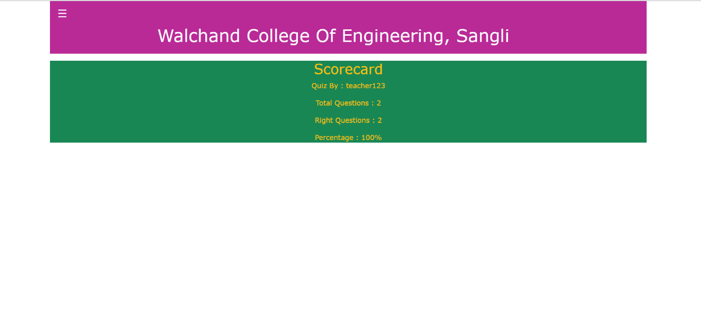

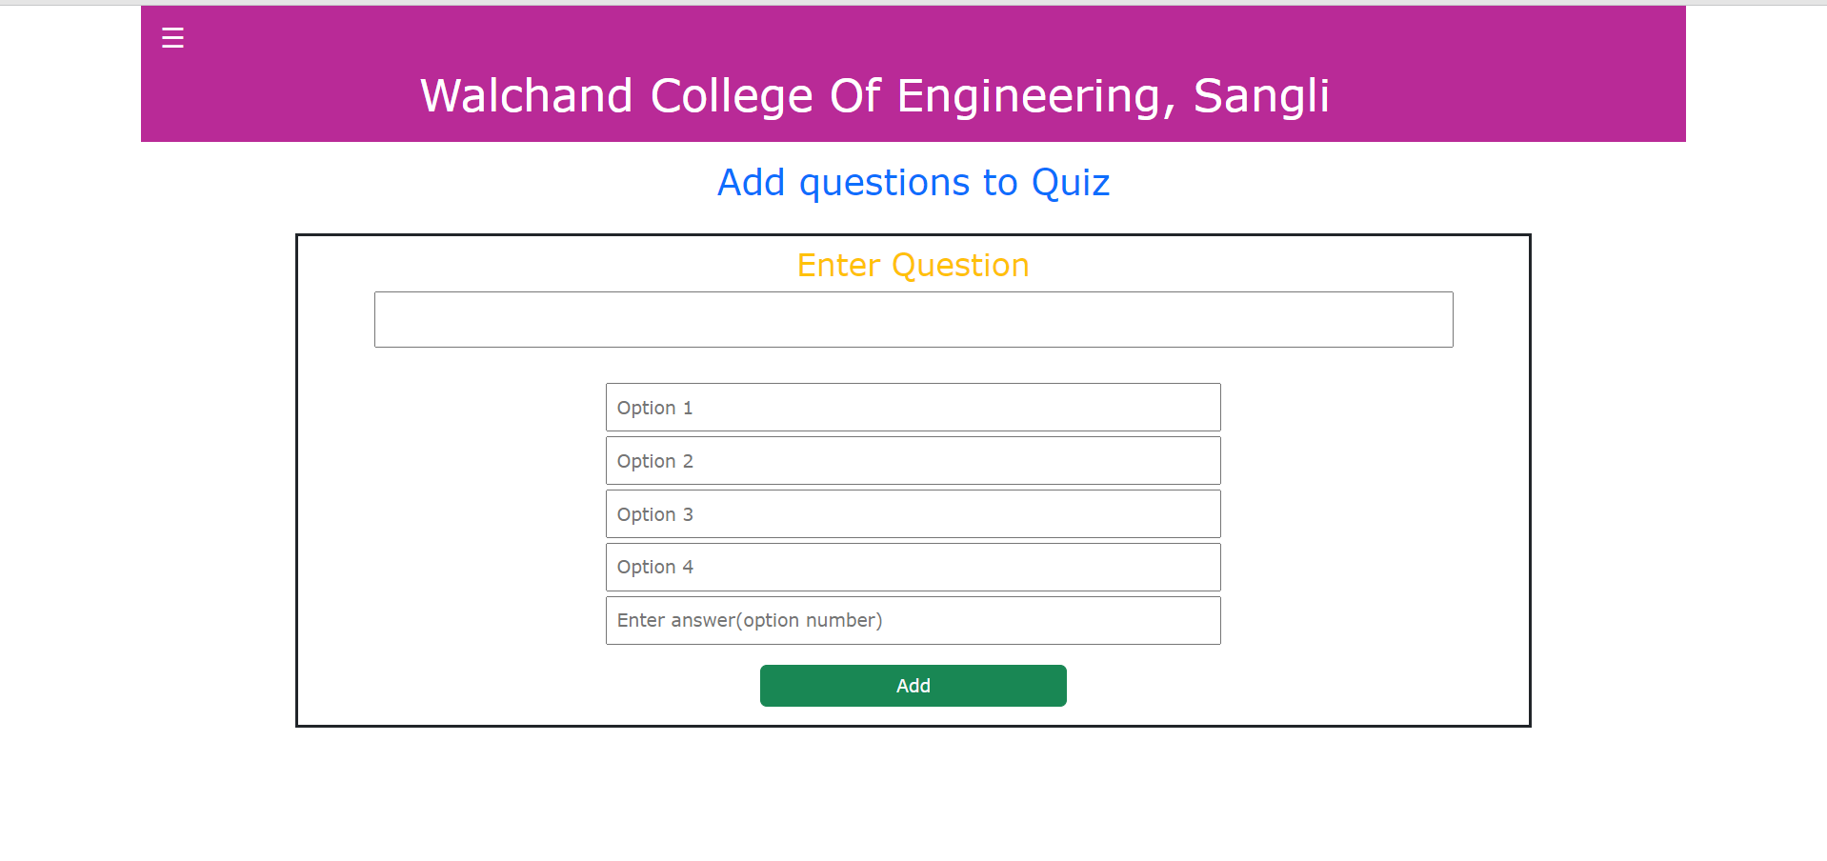

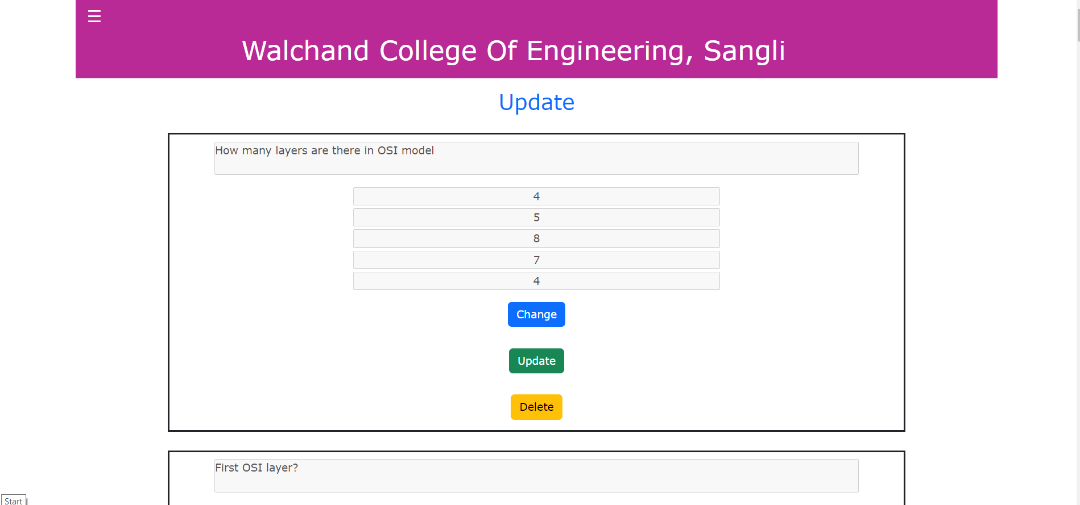

**Conclusion:**

This system can be used to conduct various examinations remotely.